**DOG BREED**

**IMAGE RECOGNITION**

**PROECT REPORT PHASE-I**

**MPW201**

Submitted By

Ishika (DD22111501004)

In partial fulfillment of the requirements for the award of the degree of

**MASTER OF COMPUTER APPLICATION**

**Under the supervision of**

**Mr. Gaurav Sharma**

**(CSE Department)**



**DEPARTMENT OF COMPUTER SCIENCE & ENGINEERING**

**HIMALAYAN SCHOOL OF SCIENCE & TECHNOLOGY,**

**SWAMI RAMA HIMALAYAN UNIVERSITY**

**SWAMI RAM NAGAR, JOLLY GRANT-248016, UTTRAKHAND**

**Odd Semester, 2023-24**

**TABLE OF CONTENTS**

**Contents Page No.**

**Certificate 1**

**Declaration 2**

**Abstract 3**

**Acknowledgement 4**

**List of figures 5**

**List of tables 6**

**Table of Contents 7**

**CERTIFICATE**

This is to certify that **ISHIKA,** a student of **Himalayan School of Science & Technology,** has satisfactorily completed the project work of **“Dog Breed Image Recognition”** is required at the **MCA** course prescribed by the **SWAMI RAMA HIMALAYAN UNIVERSITY** during the year 2022-2024.

**Guide By:**

**Mr. Gaurav Sharma**

**Asst. Professor CSE Department, HSST SRHU**

**(i)**

**DECLARATION**

We here by declare that the work which is being presented in the Project report entitled, **“Dog Breed Image Recognition”** submitted by us in partial fulfillment of the requirements for the award of degree of **Master of Computer Application** under the supervision of **Mr. Gaurav Sharma** and refers other developer works which are duly listed in the reference section.

The matter presented in this Project Report has not been submitted for the award of any other degree of this or any other university.

This is to certify that the above statement made by the candidate is correct and true to the best of my knowledge.

**Ishika**

**Mr. Gaurav Sharma**

**Asst. Professor CSE Department, HSST SRHU**

**(ii)**

**ABSTRACT**

Dogs are one of the most common domestic animals. Due to a large number of dogs, there are several issues such as population control, decreased outbreak such as Rabies, vaccination control, and legal ownership. At present, there are over 300 dog breeds. Each dog breed has specific characteristics and health conditions. In order to provide appropriate treatments and training, it is essential to identify individuals and their breeds. Machine learning gives the strength on the thanks to train algorithms model which will handle the difficulties of information classification also prediction grounded on totally on arising information as of raw information. Convolutional Neural Networks (CNNs) gives single often used methods for image classification and detection. In this exertion, we define a CNN based approach for spotting dogs in perchance complex images and due to this fact reflect inconsideration on the identification of the one of kinds of dog breed. The experimental outcome analysis supported the standard metrics and thus the graphical representation confirms that the algorithm (CNN) gives good analysis accuracy for all the tested datasets.

Image Classification is becoming increasingly important in the digital world and has applications that go far beyond just facial recognition for humans. Image Classification, especially fine-grained image recognition, has important applications in industries ranging from social media to marketing to national security. We wanted to take this important method and apply it do something we all love…dogs! Have you ever seen a dog walking down the street and wondered “ what type of dog is that”? If so, you are not alone. Dog breed identification models can be used not only to satisfy our own curiosity, but also help predict future behavior, match dogs to owners, help return lost dogs to their homes, and aid in targeted internet advertising. In order to accomplish our goal of building a dog breed classification model, we use the Stanford Dog Dataset and a variety of transfer learning methods, as well as built from scratch models in 120 different dog breeds. We found that the Inception V3 model performed the best.

**(iii)**

**ACKNOWLEDGEMENT**

We are highly grateful to the **Dr. Vinay Avasthi** Principle, Himalayan School of Science and technology (HSST) SRHU Jolly grand, for providing this opportunity to carry out the major project work.

The constant guidance and encouragement received from **Mr. Gaurav Aggarwal** CSE Department, HSST SRHU has been of great help in carrying out the project work and is acknowledged with reverential thanks.

We would like to express a deep sense of gratitude and thanks profusely to **Mr. Gaurav Sharma**, without his wise counsel and able guidance, it would have been impossible to complete the project in this manner.

We express gratitude to other faculty members of computer science and engineering department of HSST SRHU for their intellectual support throughout the course of this work.

Finally, WE are indebted to all whosoever have contributed in this report work.

**Ishika**

**(iv)**

**LIST OF FIGURES**

**Fig. No. Figure Description Page No.**

**(v)**

**LIST OF TABLES**

**Table. No. Table Description Page No.**

**(vi)**

**TABLE OF CONTENTS**

**Contents Page No.**

**Chapter 1: Introduction**

1.1 Introduction of Project.

1.2 Project (Internet based, Application or System Development, Research based, Industry Automation, Network or System Administration).

1.3 Objectives.

1.4 Problem Formulation.

1.5 Identification / Reorganization of Need.

1.6 Existing System.

1.7 Proposed System.

1.8 Unique Features of the System (if any).

**Chapter 2: Requirement Analysis and System Specification**

2.1 Feasibility study (Technical, Economical, Operational).

2.2 Software Requirement Specification Document which must include the following: (Data Requirement, Functional Requirement, Performance Requirement, Dependability Requirement, Maintainability requirement, Security requirement, Look and feel requirement).

2.3 Validation.

2.4 Expected hurdles.

2.5 SDLC model to be used.

**Chapter 3: System Design**

3.1 Design Approach (Function oriented or Object oriented).

3.2 Detail Design.

3.3 System Design using various Structured analysis and design tools such as: DFD’s, Data Dictionary, Structured charts, Flowcharts or UML

3.4 User Interface Design.

3.5 Database Design.

3.6 ER Diagrams

3.7 Normalization.

3.8 Database Manipulation.

3.9 Database Connection Controls and Strings.

3.10 Methodology.

**(vii)**

**Chapter 4. Implementation, Testing, and Maintenance**

4.1 Introduction to Languages, IDE’s, Tools and Technologies used for Implementation

4.2 Coding standards of Language used

4.3 Project Scheduling using various tools such as PERT, GANTT charts, Open PROJ etc.

4.4 Testing Techniques and Test Plans

**Chapter 5. Results and Discussions**

5.1 User Interface Representation (of Respective Project)

5.2 Brief Description of Various Modules of the system

5.3 Snapshots of system with brief detail of each

5.4 Back Ends Representation (Database to be used)

5.5 Snapshots of Database Tables with brief description

**Chapter 6. Conclusion and Future Scope References.**

**(viii)**

**CHAPTER 1: INTRODUCTION**

* 1. **Introduction of Project**

Image recognition and classification have successfully applied in various domains, such as face recognition [[1](javascript:;)1,1[2](javascript:;)] and scene understanding for autonomous driving [1[3](javascript:;)]. At present, human face identification is successfully used for authentication and security purposes in many applications. Therefore, there are attempts to extend studies from human to animal recognition. In particular, dogs are one of the most common animals. Since there are more than 300 dog breeds, dog breed recognition can be an essential task in order to provide proper training and health treatment. Previously, dog breed recognition is done by human experts. However, some dog breeds might be challenging to evaluate due to the lack of experts and the difficulty of breeds' patterns themselves. It also takes time for each evaluation.

The World Canine Organization ([FCI](http://www.fci.be/en/)) is currently listing more than 300 officially recognized dog breeds. Over thousands of years, mankind has managed to create an impressive diversity of canine phenotypes and an almost uncanny range of physical and behavioral characteristics of their faithful four-legged friends. However, apart from cynology scholars, dog breeders and some proven dog lovers most people shrug their shoulders in a clueless gesture, when asked to name the breed of a randomly presented dog, at least when it is not exactly a representative of one of the most popular and well-known breeds like Basenji, German Shepard or pug. If you are one of the few people who finds it slightly embarrassing not being able to identify dogs like a cynologist, you are probably pleased to learn that there might be a technical solution. Because thankfully, the aspiring and astonishing field of Deep Learning and artificial neural networks provides powerful concepts and methods for addressing this sort of classification tasks.

In this project we will develop ideas for a dog identification app using deep learning concepts. The software is intended to accept any user-supplied image as input. If a dog is detected in the image, it will provide an estimate of the dog’s breed. If a human is detected, it will provide an estimate of the dog breed that is most resembling.

* 1. **Project Category**

The goal of this project is to classify images of dogs according to their breed. When the image of a human is provided, it recommends the best resembling dog breed. I decided to opt for this project as I found the topic of Deep Neural Networks to be very fascinating and wanted to dive deeper into this with some practical work.

* 1. **Objective**

The main objective of this project is to Building a fine-grained image classification model which classifies dog breeds. Achieving a high level of accuracy is a significant challenge due to the large variance in the same subcategory (breed) while also having a small variance between different subcategories.

* 1. **Problem Formulation**

**Problem 1.** The main problems addressed by this project are to classify images of dogs according to their breed using [CNN (Convolutional Neural Networks)](https://en.wikipedia.org/wiki/Convolutional_neural_network) and implementing a web application to provide online dog breeds detection. Detecting dog breed is extremely challenging, even for humans.

**Problem 2. Evaluation Metrics**

Given this project is a classification problem and the scope is simple, we are going to use accuracy score to evaluate the model in training and test set. Accuracy works well when the dataset classes are balanced.

As presented in the next section, we don’t have a uniform distribution of classes in our dataset but it is balanced enough to use this metric to evaluate the quality of our models.

**Problem 3.** The pet industry is huge and ever growing. Dogs are the most preferred pets. Currently, the only way to find the breed of a dog, is to inquire about it from either the owner of the dog or the professionals in the industry. This can be a time consuming and confusing experience for a prospective dog owner. Finding the breed of a dog should be as easy as snapping a picture. However, currently there is a lack of an application that addresses this market need. In this paper, we have built an app for the android platform that uses Convolutional Neural Networks (CNN) and Transfer learning to identify the breed of a dog by simply snapping a picture of it.

* 1. **Identification**
  2. **Existing System:**
  3. **Proposed System**

In a propose system, we are proposed experiment on detecting dog breed by taking image as input and to provide best accuracy we have used limited set of supervised data. We come through a wide range of different and major algorithms for predicting or classifying the images. CNN (Convolutional Neural Network) is a deep machine learning algorithm and it used for image classification and detection for big dataset, we will be using CNN in our project to detect the Dog-breed.

The proposed framework of dog breed classification is shown in [Fig. 3](javascript:;). It consists of 3 main phases, which are data preparation, training and testing. Since we focus on dog face images, the data preparation step is required. Then, it is split for the training process and testing process. The output from the training model is a dog breed model. The model is used for breed classification and model evaluation. Details are explained in the following subsections.

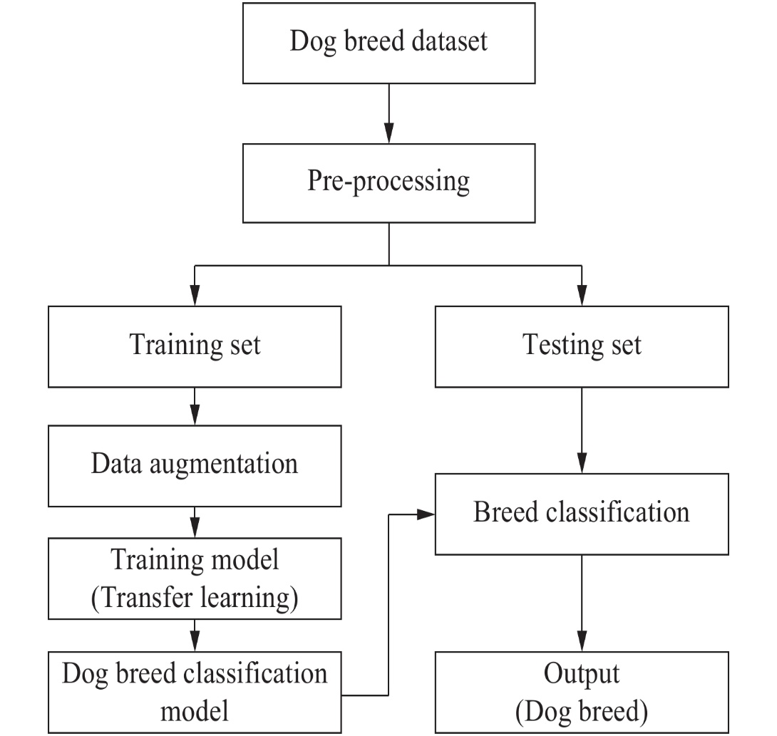

**Figure 3.**  Overview of the proposed framework

**Data preparation**

In this study, we create dataset to evaluate our method. It contains 1460 dog images of 10 breeds Given the original images, it requires some pre-processing such as resizing and rescaling to extract dog faces. The pre-processed data is then split into a training set and testing set. The training set is augmented using data wrapping techniques such as rotation, flipping and adding noise.

**Dog breed classification model**

In this report, the dog breed classification model is constructed by using transfer learning techniques. With transfer learning, we can train the model with a small dataset by using existing pre-trained CNNs from a large dataset such as ImageNet. The model takes dog face images as the input and creates CNN features using an ImageNet weight. Then it retrains the last fully connected layers with our dog breed data to build a new classifier.

In order to test the dog breed classification model, we use the testing set that is split from the data preparation phase. Dog face images in the testing set are fed into the dog breed model, which is trained from the training phase. Then the model output is a predicted dog breed.

**CHAPTER 2: REQUIREMENT ANALYSIS AND SYSTEM SPECIFICATION**

* 1. **Feasibility Study**

A feasibility study for the "Dog Breed Image Recognition and Learning" project can be carried out by examining the technical, economic, and operational aspects of the project.

1. **Technical Feasibility**:
2. **Operational Feasibility:**
3. **Economic Feasibility**:
   1. **Software Requirement Specification Documents**

A Software Requirements Specification (SRS) document is a comprehensive description of the requirements for a software system. It is a crucial document that outlines the functional and non-functional requirements of the software system. The SRS document is used as a reference by the development team to ensure that the software system meets the requirements of the stakeholders.

● **General description:** This section should describe the general functions of the product, including the objective of the user, user characteristics, features, benefits, and why it is important.

● **Functional Requirements:** This section should describe the possible outcomes of the software system, including the effects due to the operation of the program. All functional requirements, which may include calculations, data processing, etc., should be placed in a ranked order. Functional requirements specify the expected behavior of the system-which outputs should be produced from the given inputs. They describe the relationship between the input and output of the system. For each functional requirement detailed description of all the data inputs and their source, the units of measure, and the range of valid inputs must be specified.

● **Interface Requirements:** This section should describe the software interfaces, which mean how the software program communicates with each other or users either in the form of any language, code, or message. Examples can be shared memory, data streams, etc.

● **Performance Requirements:** This section should describe how a software system performs desired functions under specific conditions.

* 1. **Validation**
  2. **Expected hurdles**

There are several challenges that might be faced while developing a Sign language Translator system using machine learning. Here are some of the common ones:

1. **Data quality:** The quality of data is crucial for the success of machine learning models. Inaccurate or incomplete data can lead to incorrect predictions and unreliable results. Therefore, it is essential to ensure that the data is clean, consistent, and relevant.
2. **Data quantity:** Machine learning models require a large amount of data to train effectively. Collecting and processing large amounts of data can be time-consuming and expensive.
3. **Model selection:** Choosing the right machine learning model for use case scan be challenging. There are several models available, and each has its strengths and weaknesses. It is essential to select the model that best fits the use-case.
4. **Model training:** Training machine learning models can be computationally intensive and time-consuming. It is essential to have the necessary hardware and software infrastructure to train the models effectively.
5. **Model evaluation:** Evaluating the performance of machine learning model scan be challenging. It is essential to use appropriate metrics to evaluate the model’s performance accurately.
6. **Model deployment:** Deploying machine learning models in production can be challenging. It is essential to ensure that the models are integrated correctly with the existing systems and that they are scalable and maintainable.
   1. **SDLC model to be used**

**CHAPTER 3: SYSTEM DESIGN**

* 1. **Design Approach**
  2. **Detail Design**
  3. **User Interface Design.**
  4. **Database Design**
  5. **ER Diagrams**
  6. **Normalization.**
  7. **Database Manipulation**
  8. **Database Connection Controls and Strings**
  9. **Methodology**

The project flow has two parts: training and testing.

**Training:** Initially the Dog breeds images are collected. The images should be in Jpeg or PNG format. In the image processing step the images are reshaped. The feature of images extracted by the Vgg19 convolution neural network is having the 19 layers in which 16 are neural network layers, 5 are fully connected layers, soft max layer, and the max pool layers. After training process an encoded model file will be generated.

**Testing:** The input image is given to the system. The image will be resized and normalized. This is compared with the model file generated during the training purposes. After comparison, the result will be obtained. The dataset Dog breeds are collected and trained using the Convolutional neural network. After training model file is generated. The input image to be tested is compared with the model file. Input image is pre-processed and is converted to NumPy array and after normalization to Gray level it is compared with the model file. After comparing with the model file results will be obtained.

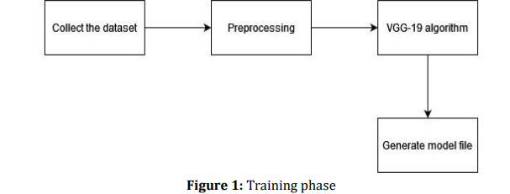

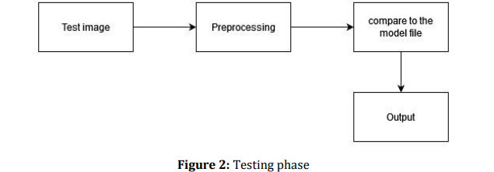

**CHAPTER 4: IMPLEMENTATION, TESTING, AND MAINTENANCE**

**4.1 Introduction to Languages, IDE’s, Tools and Technologies used for Implementation**

**4.2 Coding standards of Language used**

**4.3 Project Scheduling using various tools such as PERT, GANTT charts, Open PROJ etc.**

**4.4 Testing Techniques and Test Plans**

**CHAPTER 5: RESULT AND DISCUSSIONS**

* 1. **User Interface Representation (of Respective Project)**
  2. **Brief Description of Various Modules of the system**
  3. **Snapshots of system with brief detail of each**
  4. **Back Ends Representation (Database to be used)**
  5. **Snapshots of Database Tables with brief description**

**CHAPTER 6: CONCLUSION AND FUTURE SCOPE**

* 1. **Conclusion**

The main aim of this model is to learn that how to use a machine learning classification tool to classify images, namely, dog breeds. The application is properly proved with all sort of dog images which gives faithful and precise result. As of now this application gives a basic scraped data for each dog breed. Convolutional neural network is a learning method for data analysis and predictions, now a days it is become very famous for image classification problems. Dog breed classification of deep learning developed using convolutional neural network is to predict the breed of number of images in taking images as input. We use transfer learning on the way to build model that make output and around to number of dissimilar dog types. The results were pleasant good for the images the model was shown. The algorithm was able to identify dog breeds quite perfectly.

* 1. **Future Scope**

Future work should further explore the potential of convolutional neural networks in dog breed prediction. Given the success of our key point detection network, this is a promising technique for future projects. That said, neural networks take an enormous time to train and we were unable to perform many iterations on our technique due to time constraints. We recommend further exploration into neural networks for key point detection, specifically by training networks with a different architecture and batch iterator to see what approaches might have greater success. Also, given our success with neural networks and key point detection, we recommend implementing a neural network for breed classification as well since this has not been performed in the literature. We were unable to experiment with this approach due to the time constraints of neural networks but believe that they would match if not improve upon our classification results. Ultimately, neural networks are time consuming to train and iterate upon, which should be kept in consideration for future efforts; still, neural networks are formidable classifiers that will increase prediction accuracy over more traditional techniques.

**REFERENCES**

[1]. Knowing Your Dog Breed: Identifying a Dog Breed with Deep Learning International Journal of Automation and Computing 18(1), February 2021, 45

[2]. Dog Identification using Soft Biometrics and Neural Networks Natural Sciences and Engineering Research Council of Canada 22 July 2020

[3]. Dog Breed Prediction using Convolutional Neural Network International Journal of Engineering and Advanced Technology (IJEAT) ISSN: 2249

[4]. Breakthrough Conventional Based Approach for Do 11th Learning Information Conference on Information Technology and Electrical Engineering (ICITEE), Pattaya, Thailand

[5]. Dog Breed Classifier Using Deep Learning Jaypee 173234, Himachal Pradesh July 2019

[6]. Dog Breed Identification with Fine tuning of Pre and Engineering (IJRTE) ISSN: 2277

[7]. Recognition of Dog Breeds using Convolutional Neural Network and Visual Geometry Group International Journal of Engineering and Advanced Technology (IJEAT) ISSN: 2249 2019

[8]. Dog Breed Identification Using Convolutional Neural Networks on Android CVR Journal of Science and Technology, Volume 17, December 2019

[9]. Using Convolutional Neural Networks to Classify Dog Breeds Hsu, David Stanford University 2018

[10]. Transfer Learning on Convolutional Svetlana Yanushkevich 2018 IEEE IJARSCT ISSN (Online) 2581 Advanced Research in Science, Communication and Technology Volume 4, Issue 2, April 2021 DOI: 10.48175/IJARSCT-1024 IV.

|  |
| --- |
| [11]. S. G. Tong, Y. Y. Huang, Z. M. Tong. A robust face recognition  method combining LBP with multi-mirror symmetry for images with  various face interferences. International Journal of Automation and  Computing, vol. 16, no. 5, pp. 671–682, 2019.  DOI: [10.1007/s11633-018-1153-8](http://doi.org/10.1007/s11633-018-1153-8). |
| [12]. F. K. Zaman, A. A. Shafie, Y. M. Mustafah. Robust face  recognition against expressions and partial occlusions.   International Journal of Automation and Computing, vol. 13, no.  4, pp. 319–337, 2016. DOI: [10.1007/s11633-016-0974-6](http://doi.org/10.1007/s11633-016-0974-6). |
| [13]. J. R. Xue, J. W. Fang, P. Zhang. A survey of scene  understanding by event reasoning in autonomous driving.  International Journal of Automation and Computing, vol. 15, no.  3, pp. 249–266, 2018. DOI: [10.1007/s11633-018-1126-y](http://doi.org/10.1007/s11633-018-1126-y). |